**Chapter-3**

Existing System

**3.1 Introduction of Existing System**

**3.2 Limitations of Existing System**

**3.3 Risk of Existing System**



**3.1 Introduction of Existing System**

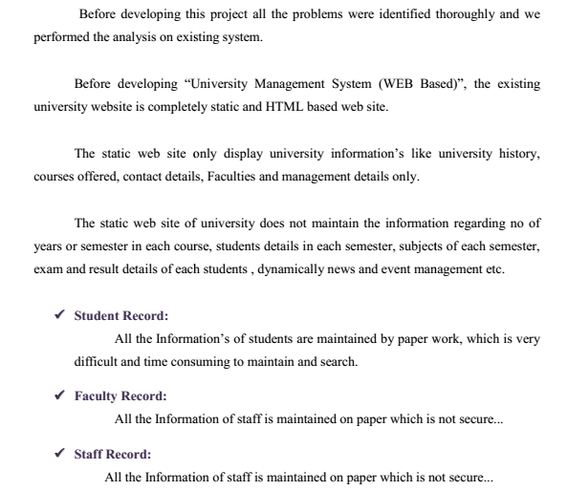 **In “School Management System (WEB Based)” some work can be done manually but some cannot be done because it is time consuming and cumbersome to do that work. This system works php-MySQL, but some data entry is necessary which cannot be avoided.**

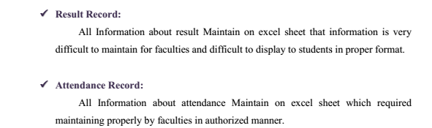

**3.2 Drawback of Existing System**

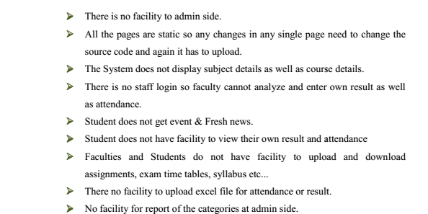

**3.3 Risk of Existing System**

